DSC 450: Database Processing for Large-Scale Analytics

Assignment Module 9

Goutham Selvakumar (2092286)

Part 1

Using the same tweets from: https://dbgroup.cdm.depaul.edu/DSC450/Module7.txt

Create a third table, now incorporating the Geo table (in addition to tweet and user tables that you already have) and extend your schema accordingly. You do not need to use ALTER TABLE, it is sufficient to just re-create (drop and create) your schema.
You will need to generate an ID for the Geo table primary key (you may use any value or reasonable combination of values as long as it is unique) for that table and link it to the Tweet table (foreign key should be in the Tweet). However, that value should be related to the location (i.e., same value for same location) – do not use a simple incremental key or a random key.
In addition to the primary key column, the geo table should have the “type”, “longitude” and “latitude” columns. NOTE: that there are no longitude/latitude dictionary keys. Instead, the geo dictionary has a 2-value tuple which are the lon/lat coordinates.
Load the tweet data into your new tables.

  - Write and execute a SQL query to do the following. Time and report the runtime of your query.

Find tweets where tweet id_str contains “789” or “987” anywhere in the column

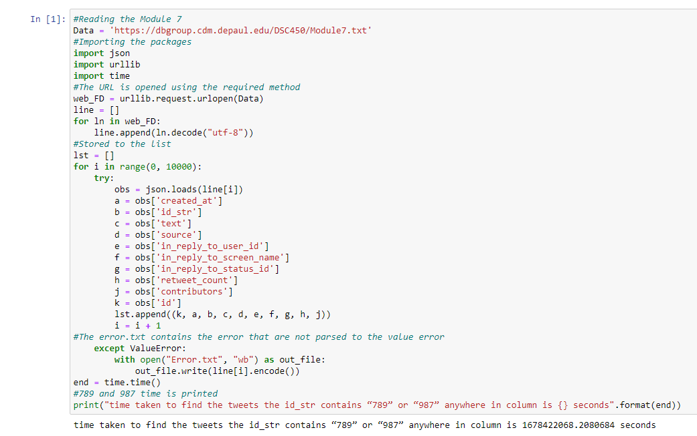
  - Write the equivalent of the previous query in python (without using SQL) by reading it from the file. Time and report the runtime of your query.

  - Write and execute a SQL query to do the following. Time and report the runtime of your query.

Find how many unique values are there in the “friends_count” column

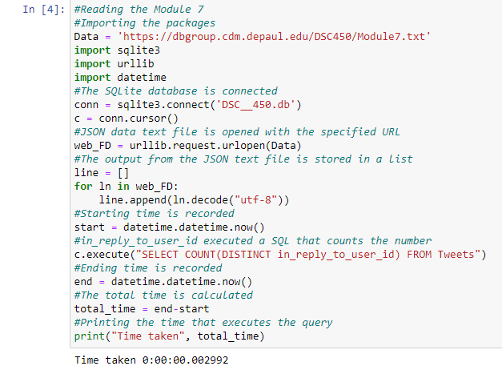

  - Write the equivalent of the previous query in python (without using SQL) by reading it from the file. Time and report the runtime of your query.

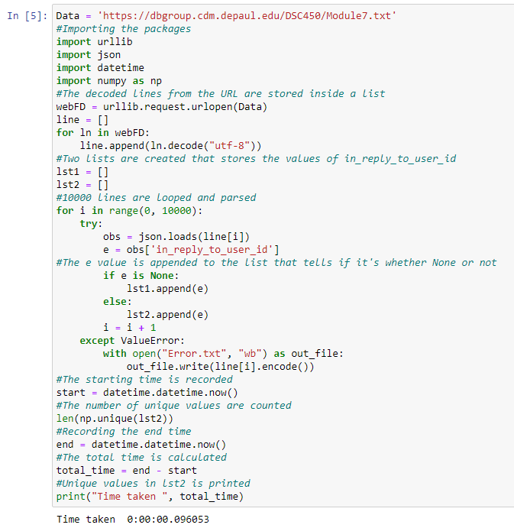

  - Use python to plot the lengths of first 80 tweets (only 80, not all of the tweets) versus the length of the username for the user on a graph. Create a scatterplot. Submit both your python code and the resulting graph file.

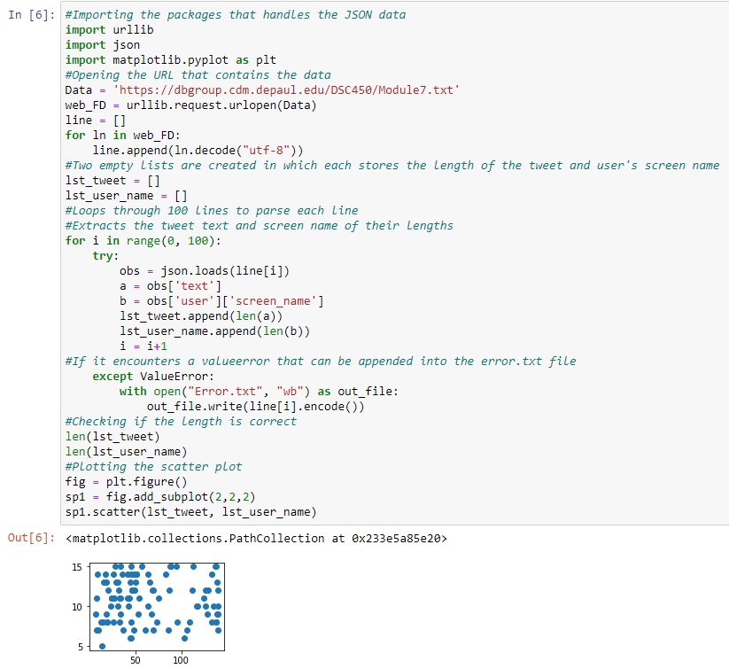

Part 2

- Create an index on userid in Tweet table in SQLite (submit SQL code for this question). These questions are as straightforward as they appear, you just need to create an index.

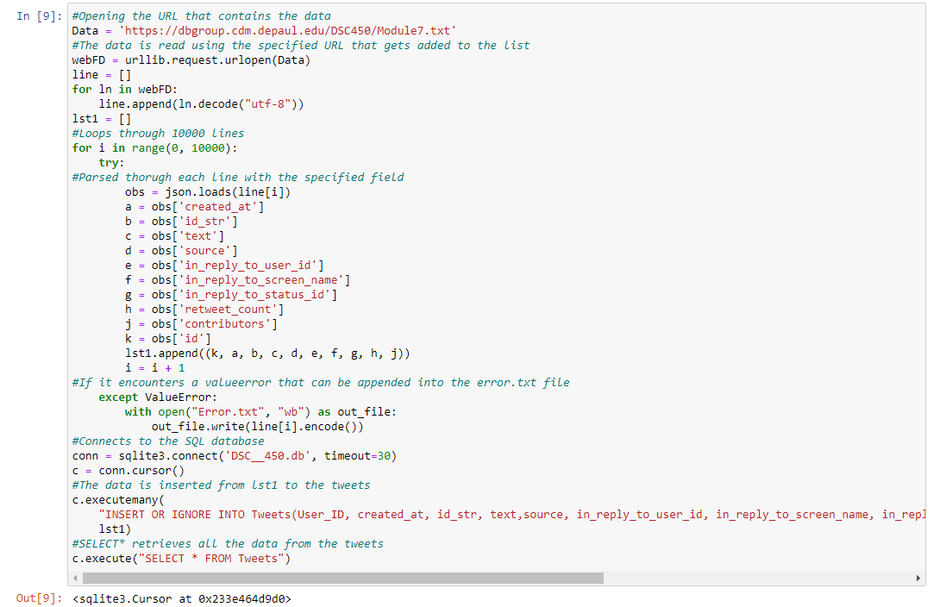

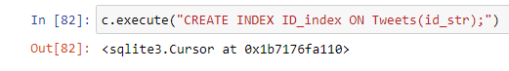

- Create a composite index on (friends_count, screen_name) in User table (submit SQL code for this question)

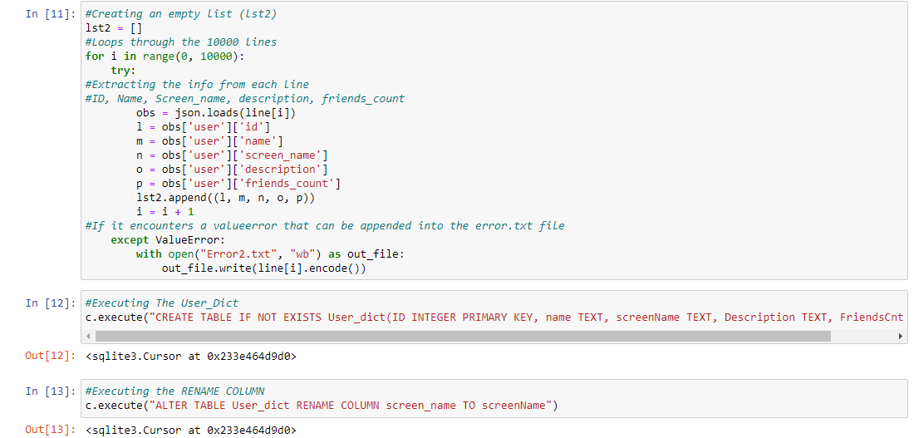

- Create a materialized view (using CREATE TABLE AS because SQLite does not have full support for MVs) that answers the query in Part-1-a. Submit your SQL code.

Part 3

- Draw a precedence graph.
Is the schedule serializable? If not, say “no”. If it is, name at least one equivalent serial schedule (e.g., <T1, T2, T3> if the execution is equivalent to individual operations executing in that order)
T1 | T2 | T3
 |  | W(A)
W(A)
 | W(C)
 |  | R(E)
W(B)
 | W(C)

The T1, T2, and T3 does not have a cycle between them and that is the reason it is conflict serializable.
The Equivalent Serial Schedule would be T2, T3, and T1.

- Draw a precedence graph.
Is the schedule serializable? If not, say “no”. If it is, name at least one equivalent serial schedule (e.g., <T1, T2, T3> if the execution is equivalent to individual operations executing in that order)

T1 | T2 | T3
 |  | R(X)
 | R(X)
 |  | W(X)
R(X)
W(X)
 |  | R(X)

There is a cycle between T1 and T3 and that’s the reason it is not conflict serializable.

T1 T2

T3

